Queen’s International Law Programs
Bader College, Herstmonceux Castle, East Sussex, U.K.
May and June 2023
Program Website: See https://law.queensu.ca/programs/jd/international-learning/bisc

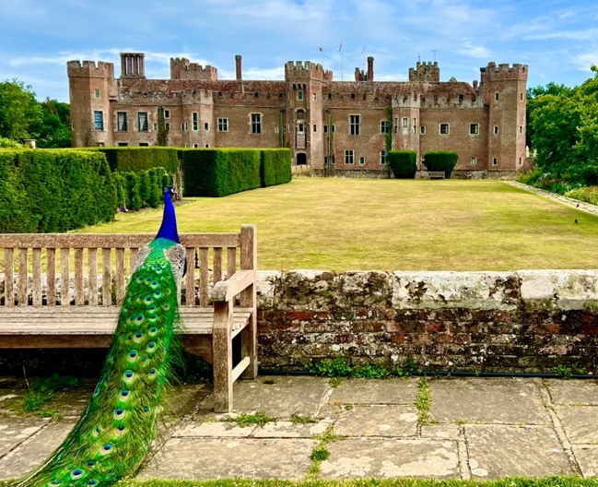
Since 2001, Queen’s Law has offered students the opportunity to enrol in our unique International Law Programs. These intensive and integrated programs in International Business Law (IBL) and Public International Law (PIL) are taught each May and June at Bader College at Herstmonceux Castle in East Sussex, England.

The programs were taught online in 2019 and 2020, and we were thrilled to return to “the castle” in 2022. We hope you will consider applying to attend in 2023.

Interested students are invited to a presentation and Q&A with the Academic and Program Directors and 2022 student participants on Friday, October 14th at 2:15 pm in room 001, followed by a social event with 2022 students.

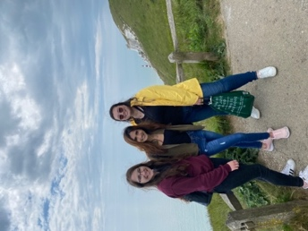
Each program consists of three three-credit upper-year courses that allow students to gain a comprehensive and practical introduction to the field of international law from leading practitioners and academics. See the IBL and PIL course descriptions on the website.

Students may use the nine credits to increase the number of courses taken in law school or to take a slightly lower course load in one or more terms, but may not use the credits to reduce to part-time status.
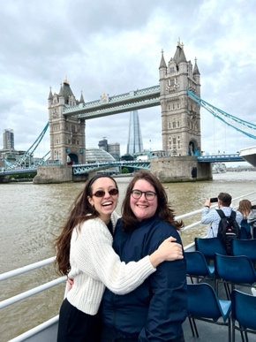
Most students attend the castle program after first year so that they will have completed nine upper-year credits before 2L summer recruitment. However, 2Ls, 3Ls, and LLM students may also participate.

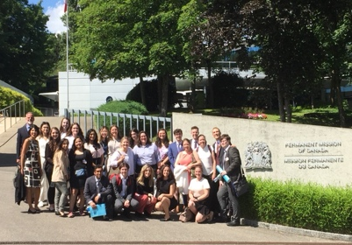
A remarkable range of distinguished instructors teach in the programs. Instructors in recent years have include a judge and prosecutors from several of the international criminal tribunals in The Hague, senior Global Affairs Canada legal officials, lawyers from leading law firms including White & Case LLP, lawyers from the UN and its agencies, and law professors from Queen’s and McGill. See details about the stellar 2022 IBL and PIL instructors, who are all expected to return in 2023, on the website.

Bader College, owned and operated by Queen’s, is on the historic 500-acre Herstmonceux Castle estate in East Sussex, England, 100 km south-east of London.

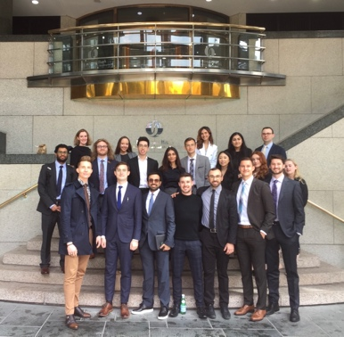
Students spend six weeks in the classroom and there are day trips to London and a week-long field studies trip to international legal organizations in Geneva (IBL program) or The Hague and Geneva (PIL program). The field trips include briefings with senior legal advisors and, where possible, senior Canadian representatives to the organizations. Typical field studies destinations are listed on the website.
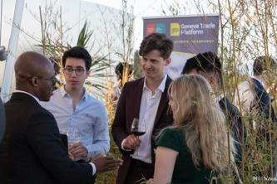
The programs also include in-class and evening guest lectures, a careers evening with alumni, and cultural tours and activities. Students also have the opportunity to apply for a limited number of internships in July and August with not-for-profit and government organizations for credit and/or a small stipend.

Information can be found on the website about the application process, fees, and bursaries and scholarships. Queen’s students have admissions priority if they apply by November 25th, 2022.

We hope to see you on October 17th. If you have any questions in the meantime, contact Gillian Ready at gillian.ready@queensu.ca. You may also want to contact some of the Student Advisors to learn about their experiences at the castle – ask Gillian to email you the list.

Student remarks in the end-of-term survey in 2022:

This experience has been a once-in-a-lifetime opportunity and probably the most meaningful thing I have ever done. The amount of personal growth I have gone through in this program is immeasurable, and for those interested in a career in international law, the connections are unparalleled.

The BISC program is wonderful. This is a unique opportunity to hear from leading experts in international law - not to mention the beautiful setting! It allows students to explore the possibilities of a career in international law.

The program really exceeded my expectations and I’m leaving with some friends that I hope I have for life!

